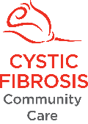

Simon's Adventure Fund
2023 Application Form
Simon's Adventure Fund has been generously established by Simon Minson's family. Its aim is to support adult CF Community Care members who have CF, to participate in an activity on their bucket list. It may be something that pushes the boundaries, it may be something that seems a little crazy. Simon was always up for an adventure. He snowboarded, skydived, bungy jumped, shot down rapids, dived with sharks, was a keen trail bike rider, got dangerously close to a brown bear in the wild, loved being behind the scenes at the zoo and played footy against guys twice his size! He chose to live his life to the full of adventures large and small. Simon died in 2014 from complications due to his CF whilst on one of these adventures with his mates in Vietnam. Simon's family want people with CF to live life to the full and so they have established Simon's Adventure Fund to assist others to fulfil their own adventure.
You may be eligible to receive one of a limited number of grants to assist with the cost of your adventure. Please read the details on page 2 for the terms and conditions and how to apply.
Applications for 2023 will close 1 December 2023 (or earlier if all grants have been distributed)

Your details
Name of person with CF: |  | CF Clinic:
Email: |  | Phone:
Address:
Suburb / Town: | State: | Postcode:

Request details
What is your adventure and where is it located?
……………………………………………………………………………………………………………………………………………………
………………………………………………………………………………………………………………………………………………………………………………………………………………………………………………………………………………………………………………………………………………………………………………………………………………………………………………………………………………………………………………………………………………………………………………………………………………………………………………………………………………………………………………………………………………………………………………………………………………………………………………………………………………………………………………………………………………………………………………………………………………………………………………………………………………………………………………………………………………………………………………………………………………………………………………………………………………………………………………………………………………………………………………………………
Why is this something you would like to do?
……………………………………………………………………………………………………………………………………………………
………………………………………………………………………………………………………………………………………………………………………………………………………………………………………………………………………………………………………………………………………………………………………………………………………………………………………………………………………………………………………………………………………………………………………………………………………………………………………………………………………………………………………………………………………………………………………………………………………………………………………………………………………………………………………………………………………………………………………………………………………………………………………………………………………………………………………………………………………………………………………………………………………………………………………………………………………………………………………………………………………………………………………………………………

How much will the adventure cost? (Include details of any airfares, accommodation, entry fees, etc)
…………………………………………………………………………………………………………………………………………………………………………………………………………………………………………………………………………………………………………………………………………………………………………………………………………………………………………………………………………………………………………………………………………………………………………………………………………………………………………………………………………………………………………………………………………………………………………
Proposed date of adventure:
I agree that if my application is successful, within four weeks of my adventure, I will provide CF Community Care with:
□ Receipts as proof of expenditure
□ Feedback about my adventure

Privacy and consent
□ I agree to the collection of the data on this form by CFCC and acknowledge that all personal information provided on this form will be placed on CFCC’s database and used for purposes associated with its service and business operations / events. It will not be provided to any other person or organisation, without my prior consent, unless required by law. The CFCC Privacy Policy provides information on how to access your personal information held by CFCC and how to seek correction of such information if required. The Privacy Policy also contains information about how to make a complaint about any breach of privacy legislation. For further details of CFCC’s Privacy Policy, view the policy online at www.cfcc.org.au/page/2/privacy
CF Community Care welcomes feedback. You can provide feedback about our programs, services and events by visiting www.cfcc.org.au/page/125/contact-us
How to apply
- Complete all sections of the Simon's Adventure Fund application form
- Send the application form to Programs and Support Services, CF Community Care at:

Email: support@cfcc.org.au
Post: PO BOX 304 Burwood NSW 1805 or 282 Neerim Rd, Carnegie VIC 3163

- We will contact you about whether your application was successful within 28 days of receiving it.

Terms and conditions
You must:
- Be a 2023 member of CF Community Care
- Be a resident of NSW or Victoria
- Be aged 18 years or older and have CF
A completed application form must be provided.
Applications for 2023 will close 1 December 2023 (or earlier if all grants have been distributed)

Need more information?
If you have any questions or would like more information about Simon's Adventure Fund or any of CF Community Care’s other services, contact us on:
 | Website:  Email:  Phone: | www.cfcc.org.au  support@cfcc.org.au  1300 023 222
Office use only
Date received: |  |  | Application successful: □ Yes □ No, why ……………………...................................................
Amount approved: |  |  | Approved by: | Date approved: | Applicant notified:
Receipts & feedback due by: |  |  | Date receipts & feedback received: | Account & job code SAF 6 - 0110 - 7375

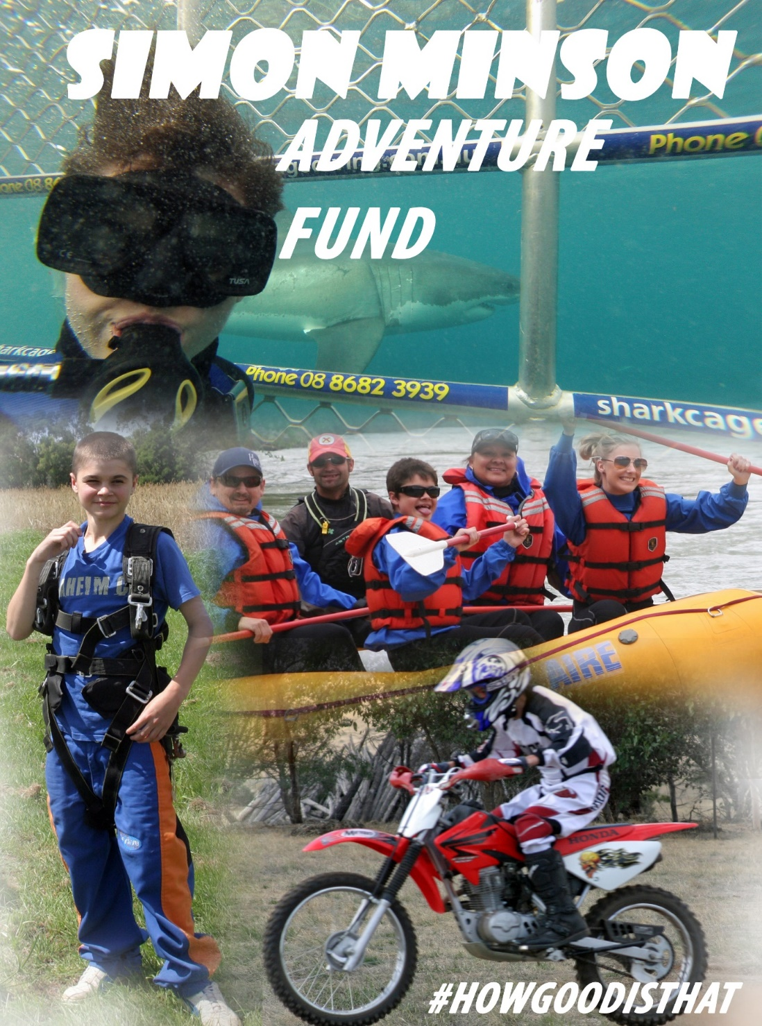

#HOWGOODISTHAT
Simon would always try to see the positive side of life. He could often be heard saying “How good is this?” or “How good is that?” From an early age he was always up for an adventure. At the age of 6 he patted a Killer Whale!
He snowboarded, skydived, bungy jumped, shot down rapids, dived with sharks, was a keen trail bike rider, got dangerously close to a brown bear in the wild, loved being behind the scenes at the zoo and played footy against guys twice his size, just to name a few.
He chose to live his life to the full with adventures large and small. He died in 2014 from complications due to his CF whilst on one of these adventures with his mates in Vietnam.
Simon’s family want people with CF to live life to the full and so they have made funds available from Simon’s estate to assist others to fulfil their own adventure.
The Adventure Fund is for adults that wish to participate in an activity on their bucket list. It may be something that pushes the boundaries a little, or even seem a little crazy.

Brief biography of Simon
- Simon was born on 11th May 1992.
- He was diagnosed with CF after 6 weeks, but we knew something was wrong in the first week and once diagnosed he spent many days in hospital undergoing tests and procedures.
- At 18 months old he had his appendix removed during a 6 week stay in hospital — and this was one of several operations to come.
- At Primary school Simon always wanted to be involved in team sports; footy, soccer, cricket — whatever was going.
- Simon played tennis for Heatherdale Tennis Club and was once filmed playing tennis for a Royal Children’s Hospital CF Research Trust fundraiser.
- The family travelled to the USA thanks to the Starlight Foundation where his main wishes were to pat a killer whale at SeaWorld, see wolves and visit Disneyland — all achieved.
- At the age of 12 he started playing for the Heathmont Jets and was given the coaches award for his under 13 season.
- Queensland was a favourite destination for Simon, doing the theme parks with family then for schoolies and later with the footy club — the Heathmont Jets.
- We toured Canada when he was 19 — a truly precious memory for us where among other things Simon had encounters with bears, saw a pod of 20 orcas, and got thrown out of a night club in Vancouver.
- At Vermont Secondary College he continued to be involved in many sporting teams and was a member of the SRC. At parent teacher nights we often got the impression from his teachers that he was their favourite lovable rogue.
- Simon barracked for the Bulldogs and despised Collingwood.
- His Bulldogs highlights were running out onto the ground with Luke Darcy on his 100th and 200th games and doing work experience at the club.
- During his Year 12 he was in hospital each term break, but still managed to do well enough to get into Monash Science. He later decided that it wasn’t for him.
- He learnt to ski, but quickly moved across to snowboarding and snowboarded at Buller, Falls Creek and in Queenstown, New Zealand.
- His first part-time job was at Pets Paradise and he later gained a permanent position at Rebel Sports where his locker remains untouched to this day — a memorial of how he was loved and respected there.
- He saved up and bought a motor bike, and loved riding it around the bush near Mansfield.
- He also worked at Healesville Sanctuary, often telling us of the amazing encounters with the animals at work.
- In the early hospital stays he and the other CF kids would get up to all sorts of mischief to kill the boredom. Nurses were constantly the victims of water fights and other pranks.
- There were the constant battles with medication and physio and very dark times of depression. But through his own inner strength and with the support of family, friends, Heathmont Football club and his medical team he got through it.
- In his last year he moved out of home and was making his own way as an adult.
- He was devoted to his pets and loved to foster rescue dogs.
- Whilst holidaying with mates in Vietnam he suffered sudden respiratory failure and was transferred to Thailand where he passed away on September 1st 2014.
- Simon’s family want to share Simon’s passion for life and adventure, with others through Simon’s Adventure Fund.

